Appendix E

User Guide

-Sandu-

After months of hard working we are finally ready to bring BBB to final step and to let people work with it!

In this user guide you will find everything you need to know how get the most out of this new application.

**Main window and log in/sign up option or exit option**

This window is the main one where you can find 3 different options on how to start working with our application:

1) You can log in by completing the necessary fields with your data and pressing “Login” button.

2) You can register your new account by pressing “Sign Up” button.

3) You can close the application by pressing “Exit” button.

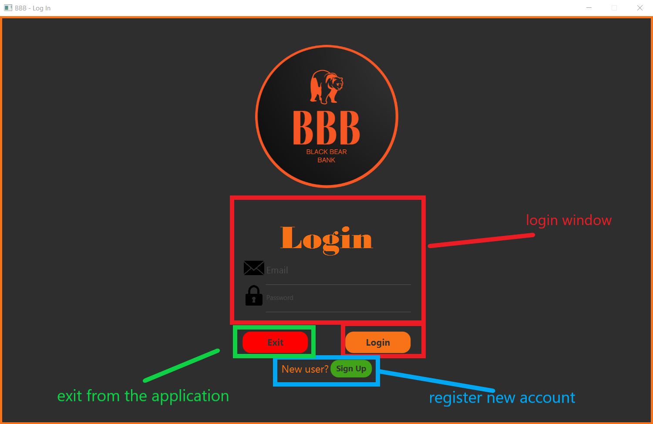

**Log in section**

Complete the fields with your personal data and press Login button. *See below how it works*:

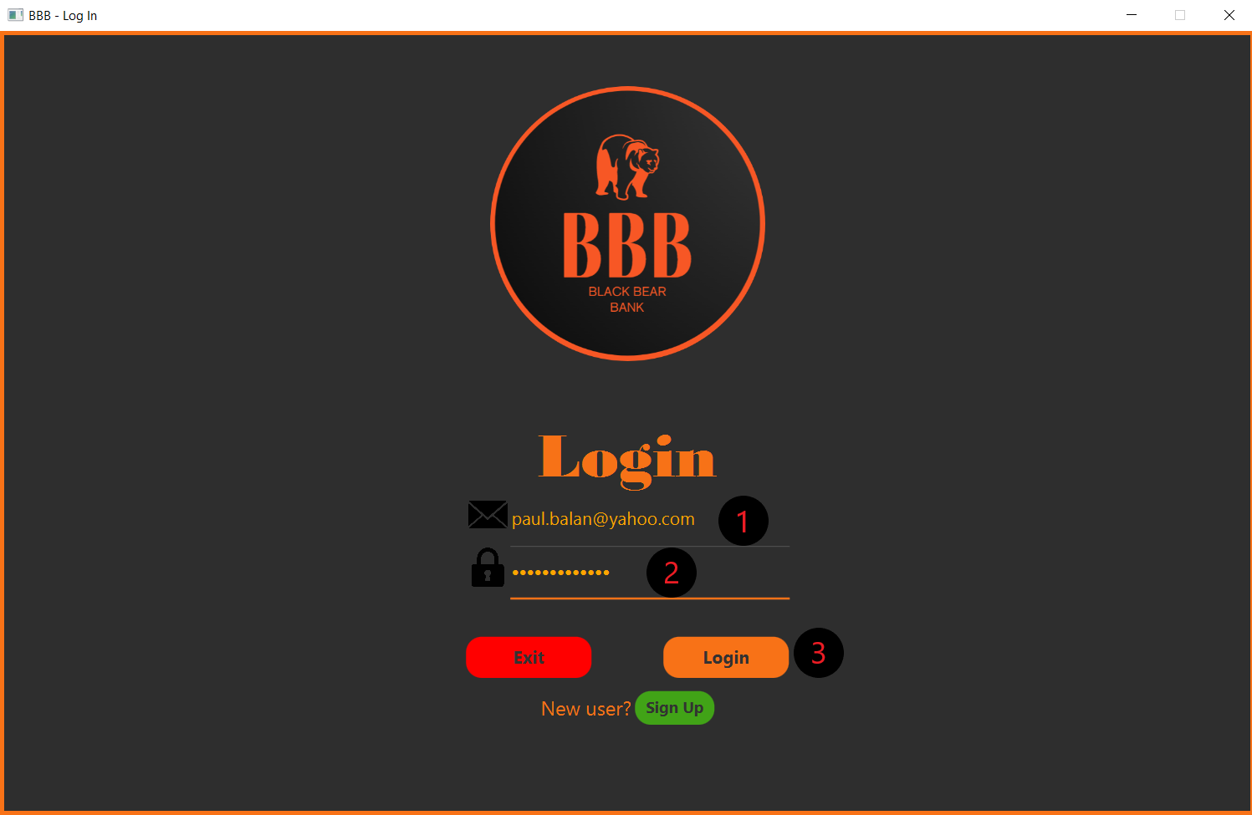

**Sign up section**

Complete the fields with your personal data and press Sign Up button. *See below how it works*: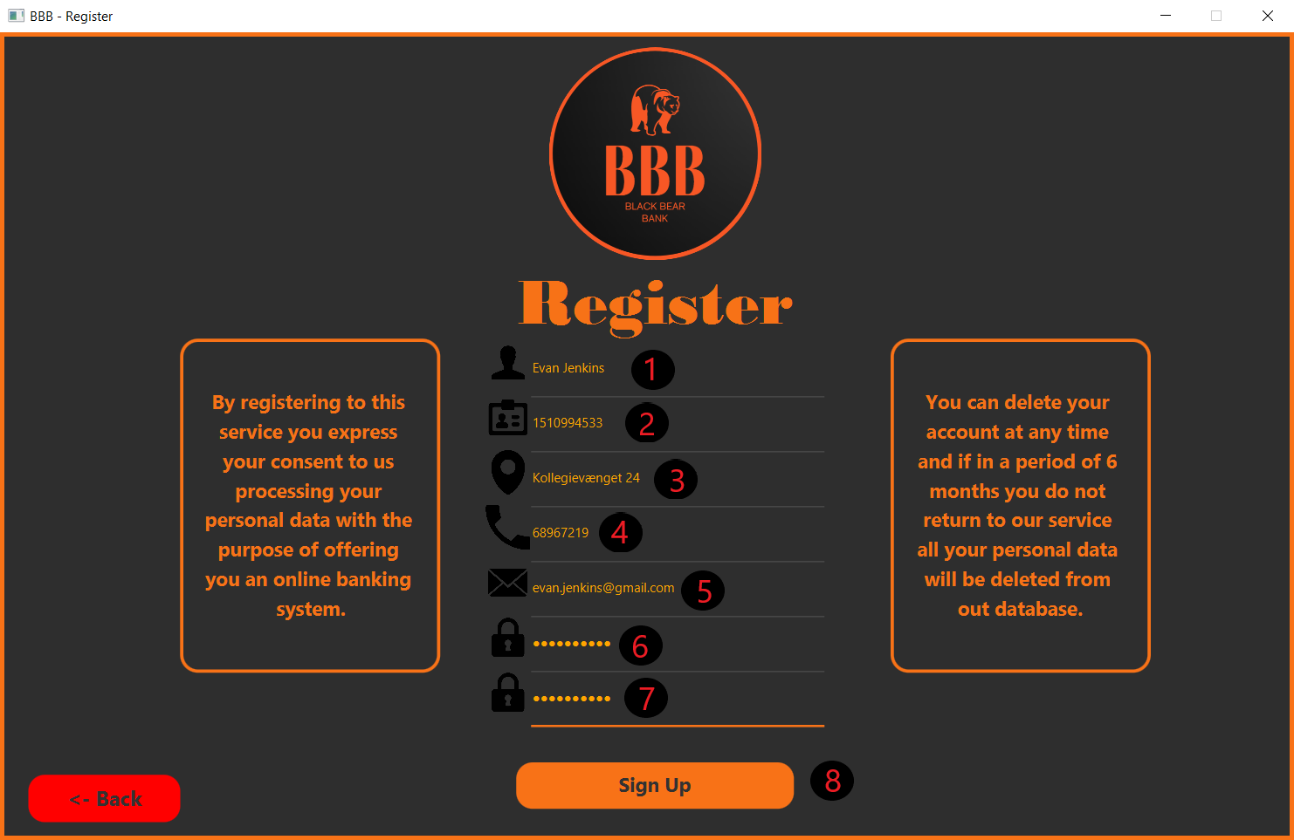

**Main menu / Home panel**

After you logged in you are facing a new window which is the main operational window used by you. 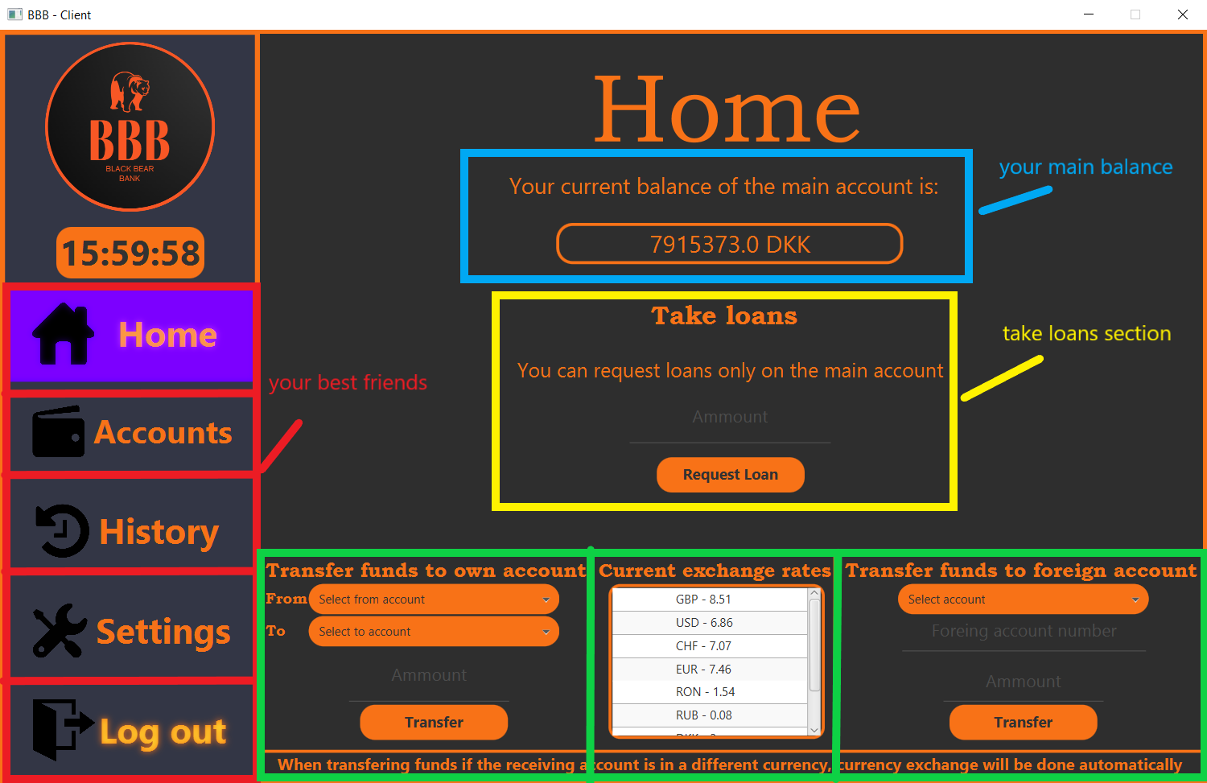

The red buttons are basically your best friends while using our application (they help you to switch to all panels which will be used).You can switch between all panels by clicking one of it.

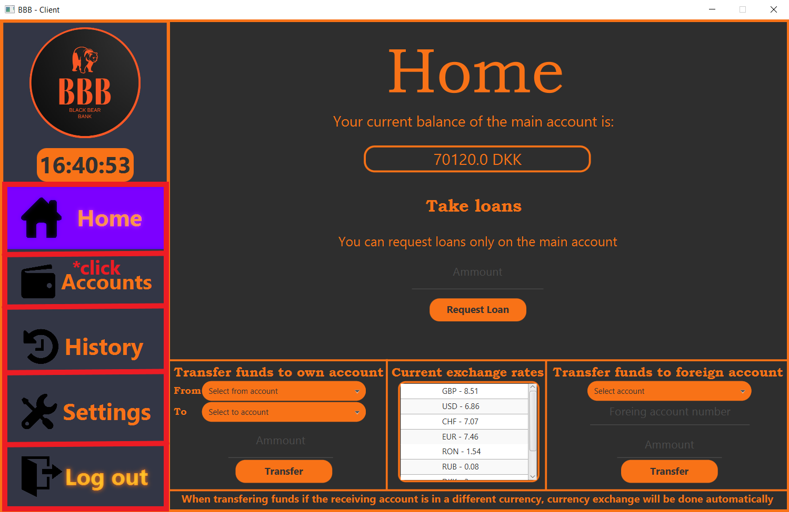

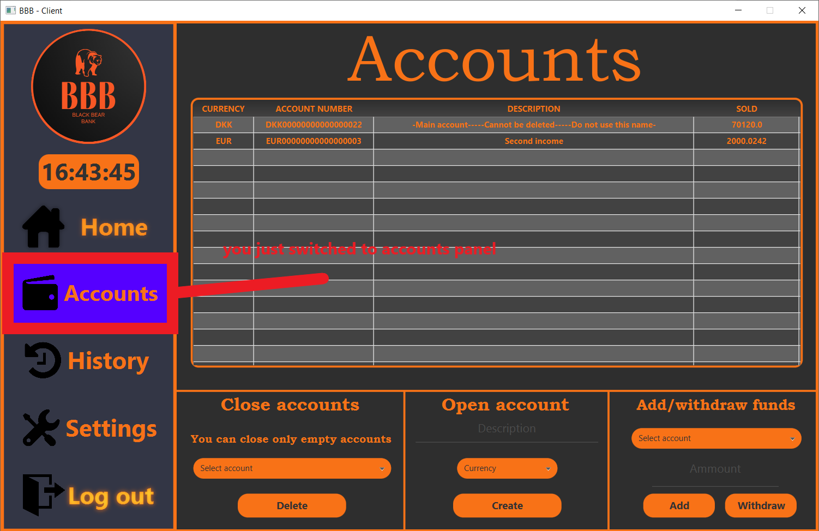

The blue border is the part where is written you main balance ( our system uses as a general and primary currency the Danish kroner DKK ) ,but don’t forget that you can operate with your money in any currency you want.

The yellow border is used for taking loans. *Here you can see how it operates*:

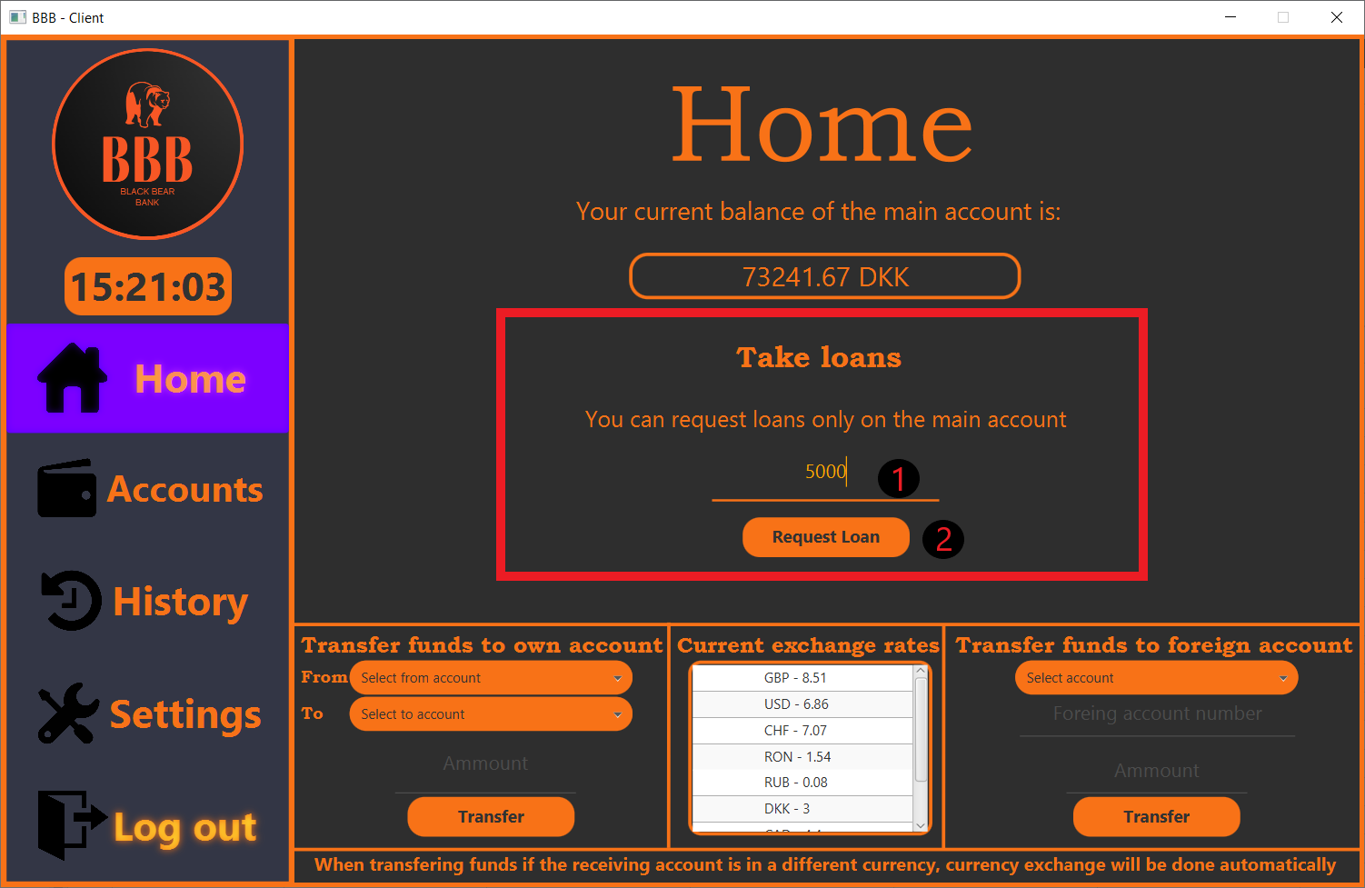

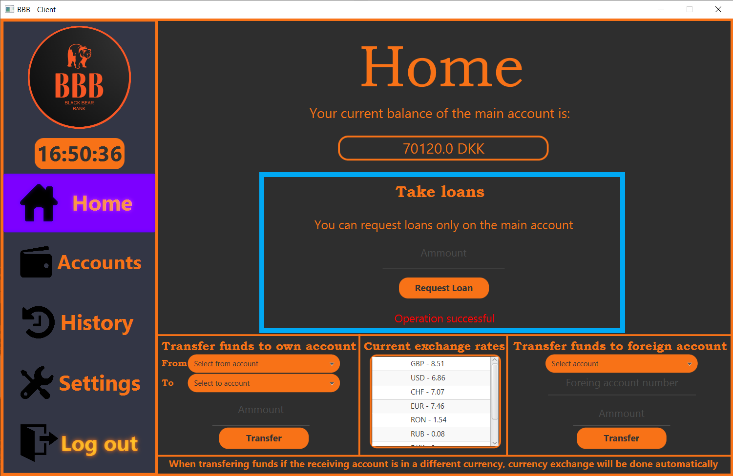

Congratulations you just took a loan of 5000 DKK – now you should wait for an approval.

The green border contain 2 main functions for your financial activities (transferring fund to your own account a foreign account and also it contains the table with all exchange rates).*Here you can see how they work*:

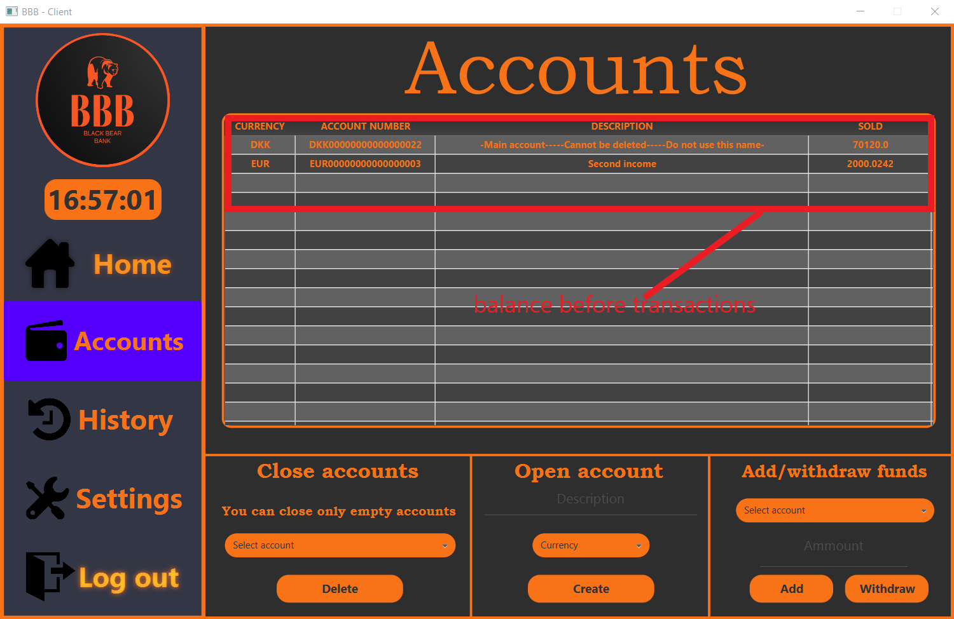

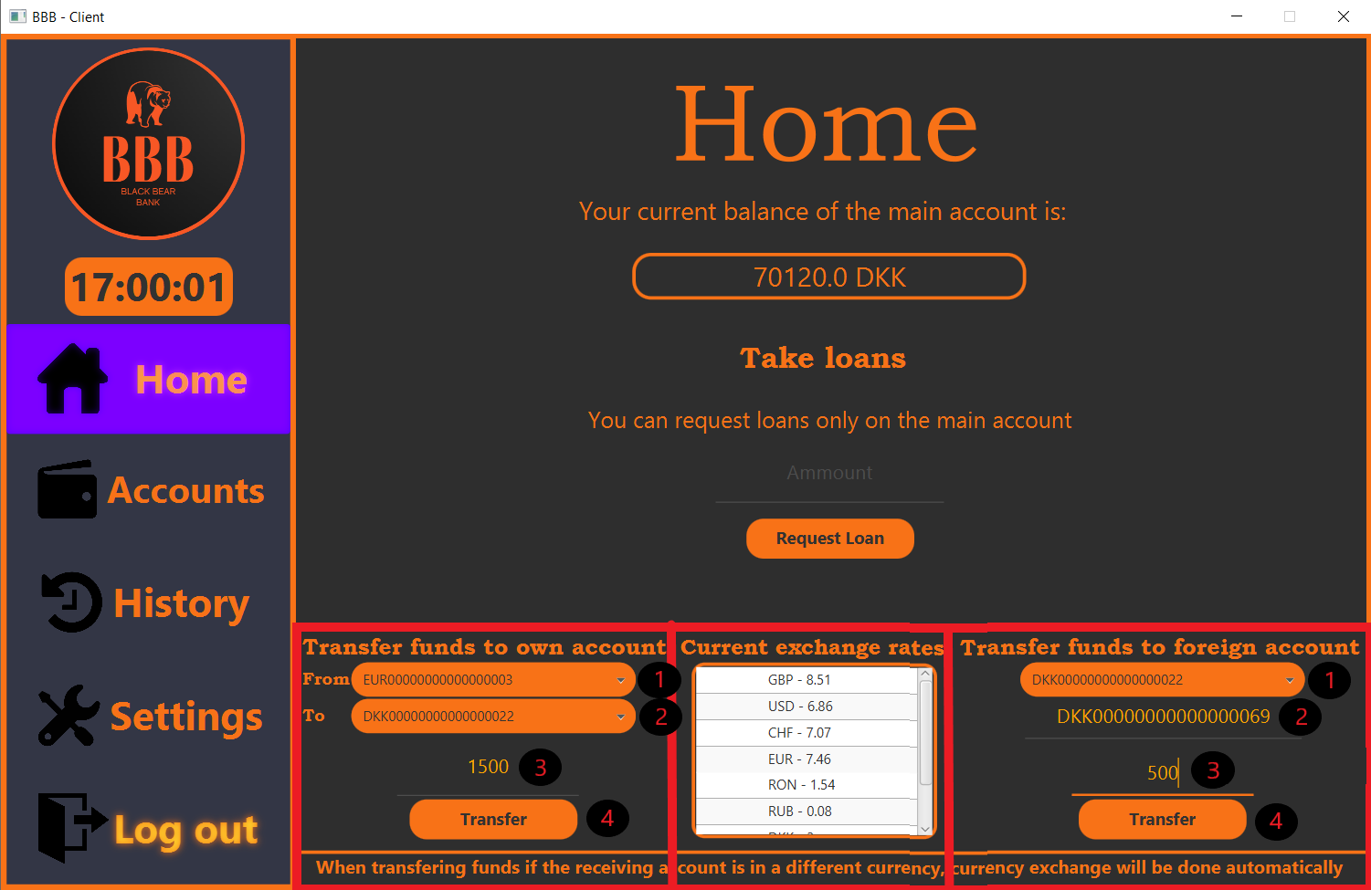

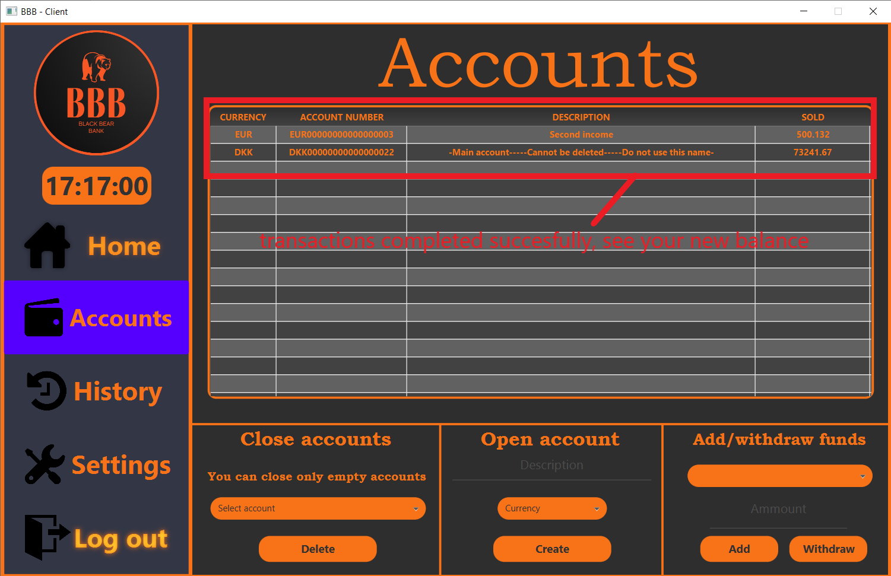

**Accounts panel**

Account panel contains the main window with all your accounts and 3 types of different operations with your accounts:

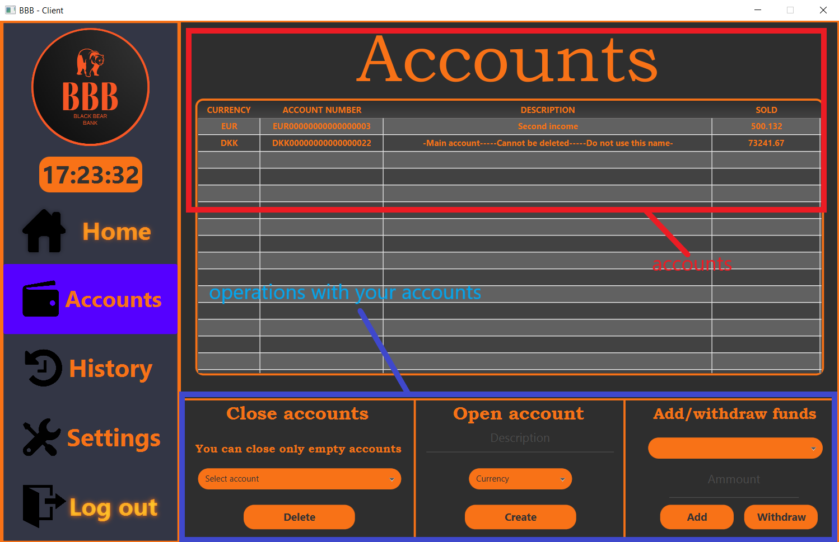

To work with your accounts you have three options. *See below how they work:*

*Note:To close one of your account. In order to close an account, it should be empty*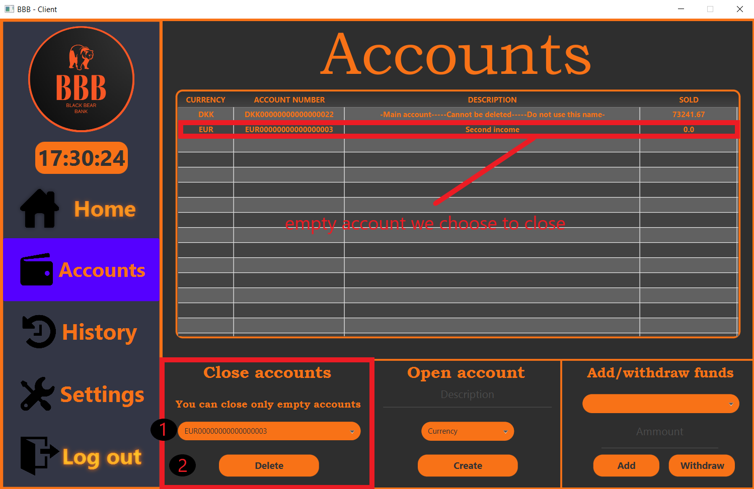

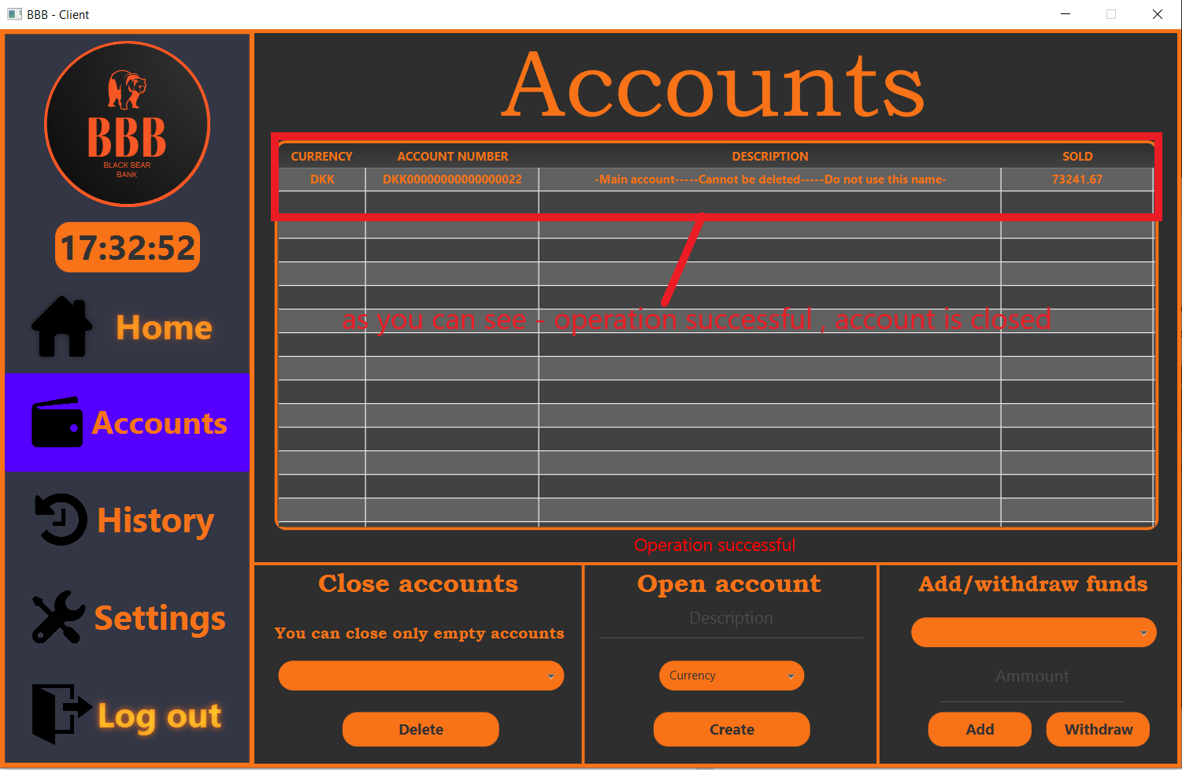

To open a new account in a chosen currency*. See below how it works*:

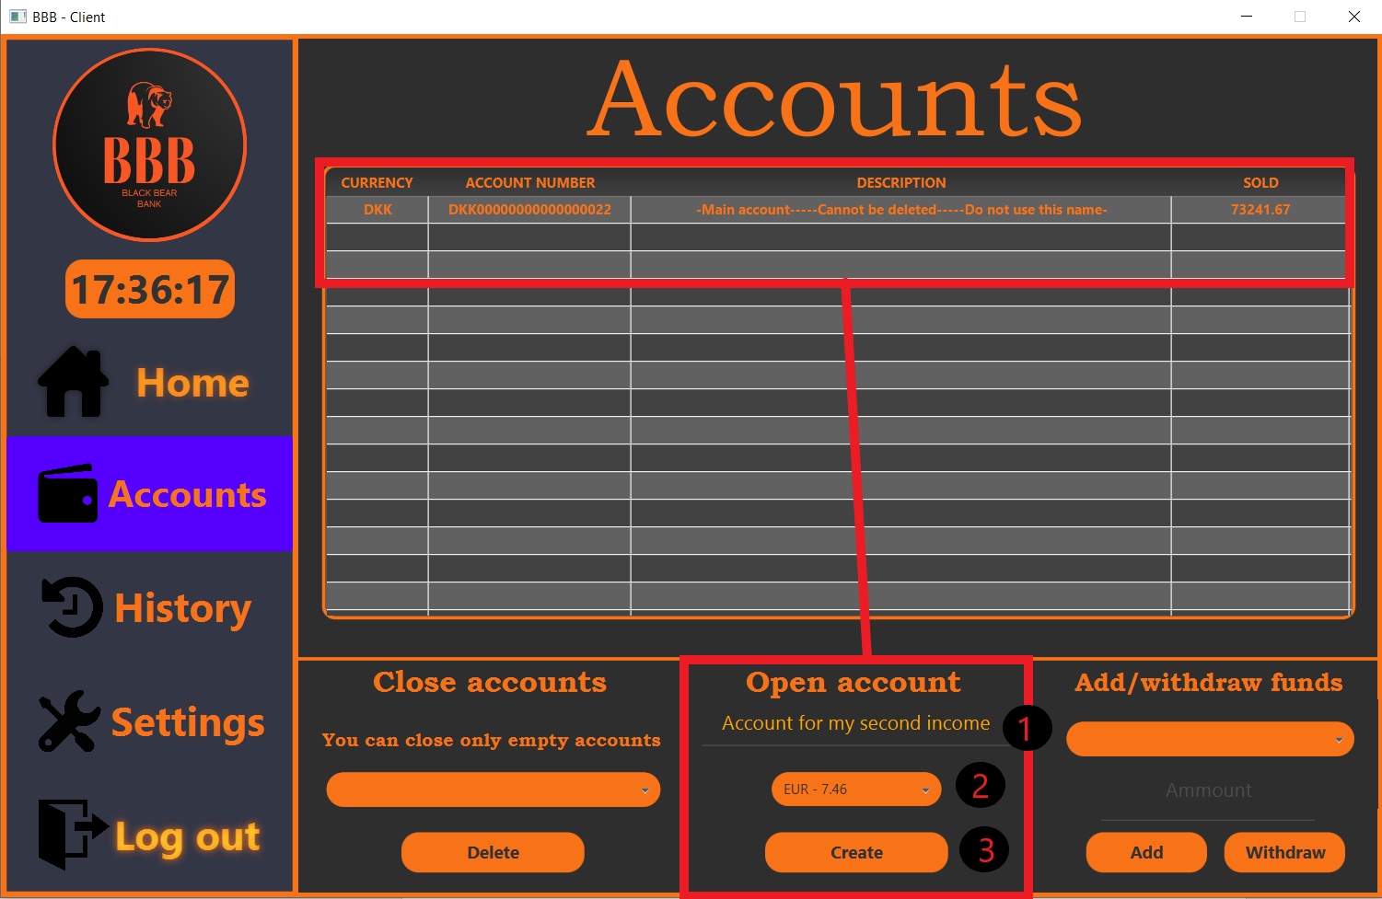

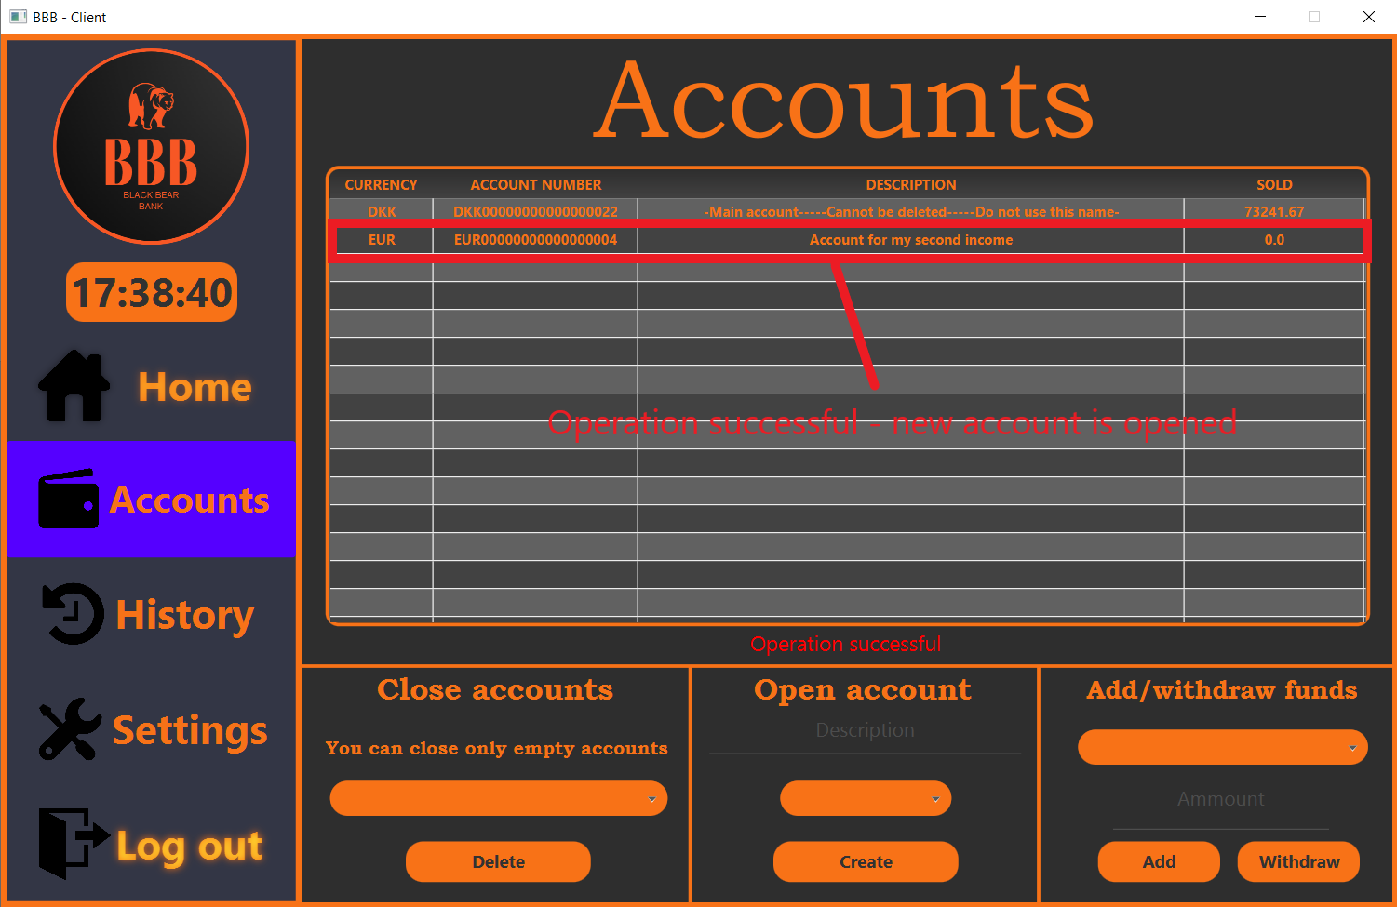

To add/withdraw funds from one of your accounts. *See below how it works*:

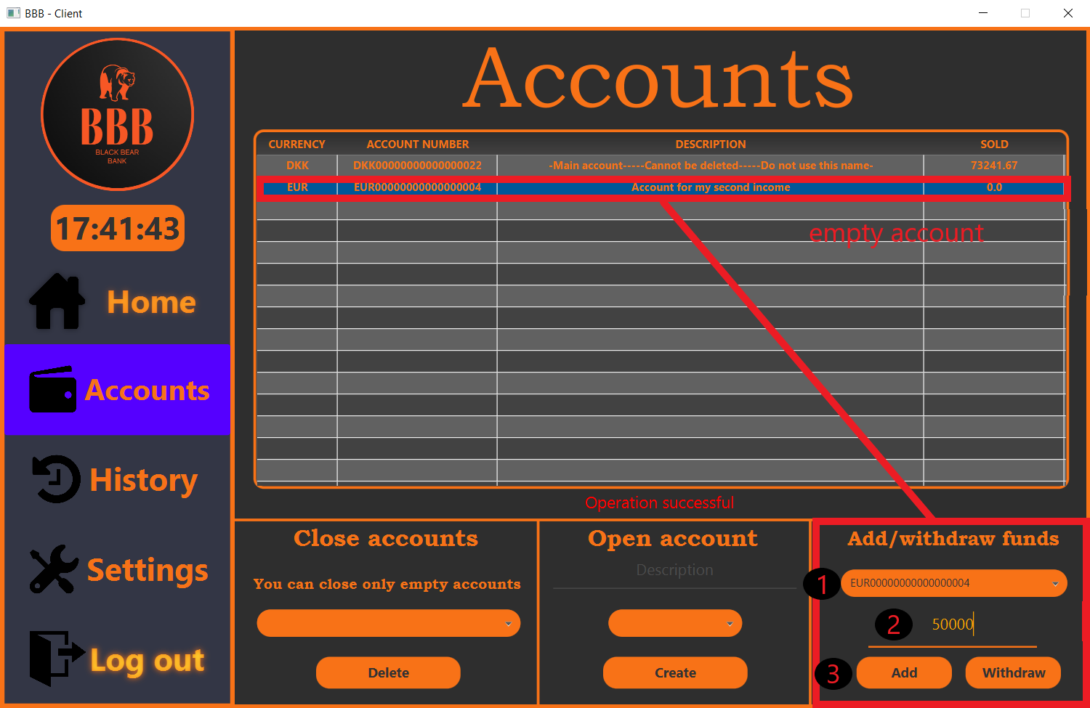

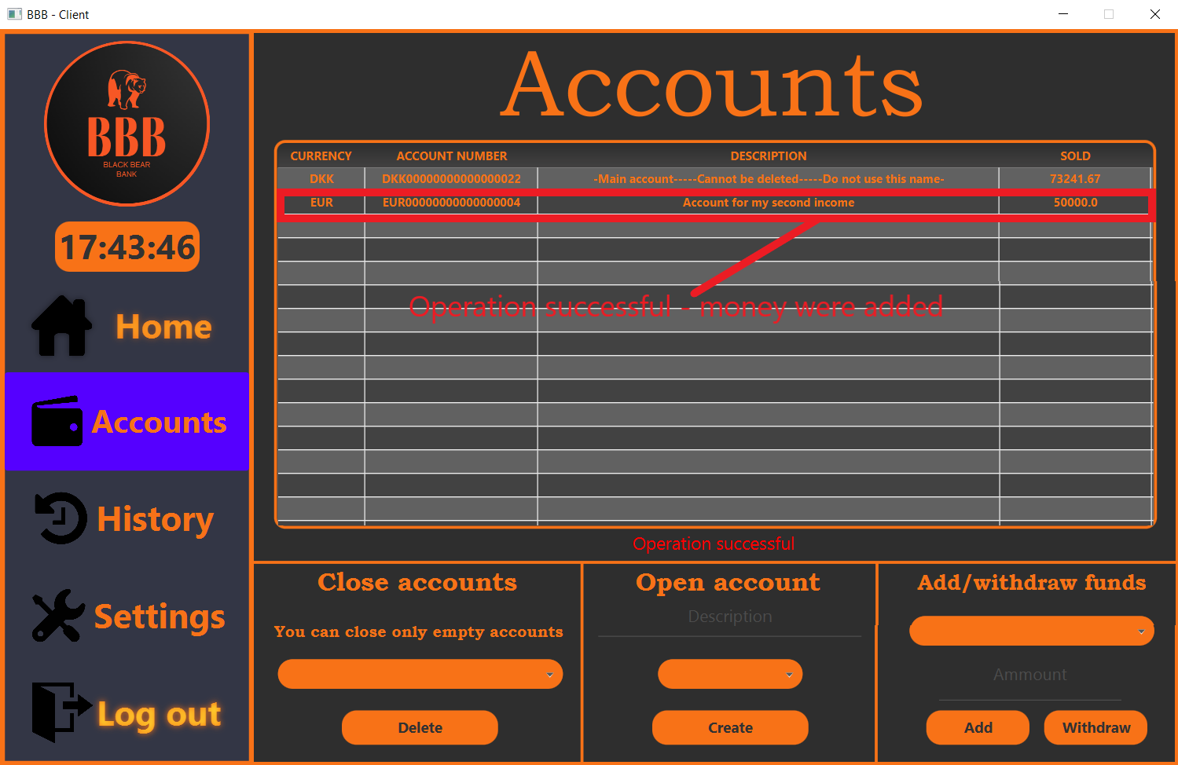

*Note: To withdraw money is the same procedure except pressing “Add” you should press “Withdraw”.*

**History panel**

History panel shows you all activities which were taken on this account. It is a very important feature for our and your security reasons.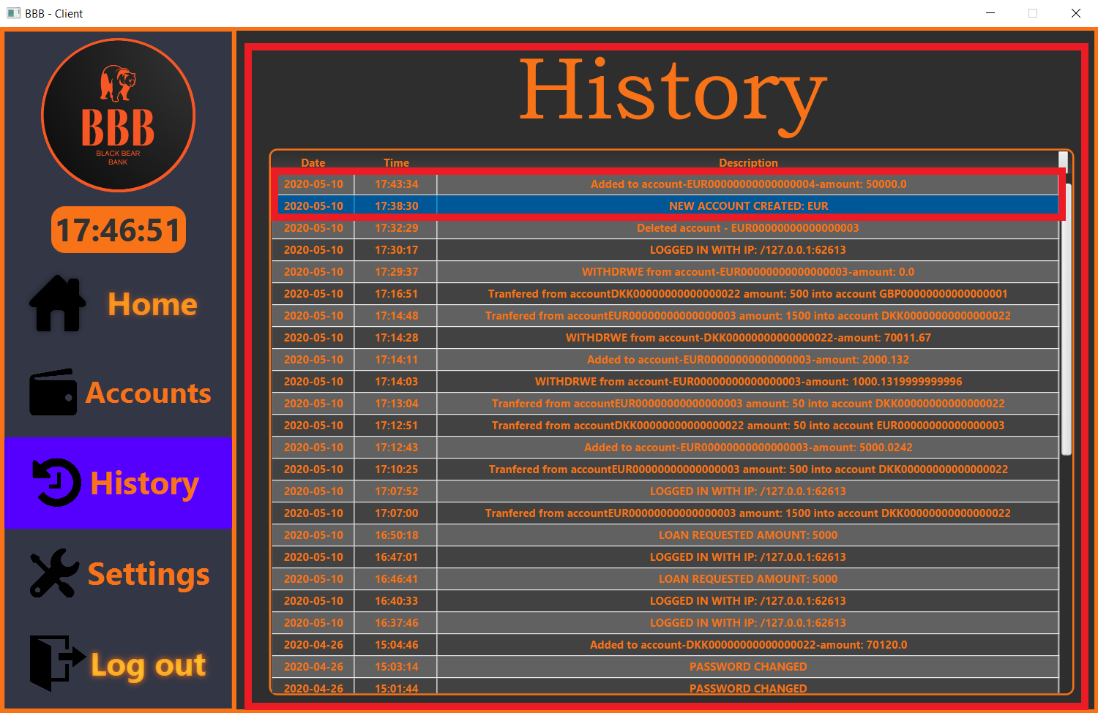

**Settings panel**

Settings panel is the panel where you can manage all your personal data.

In this panel you can see actual information about your phone number, your address and also you can change both of them, including your password and even your general account:

Red borders where you can see your actual information.

Blue border for changing your password.

Green border for changing your number.

Yellow border for changing your address.

*See below how it works*: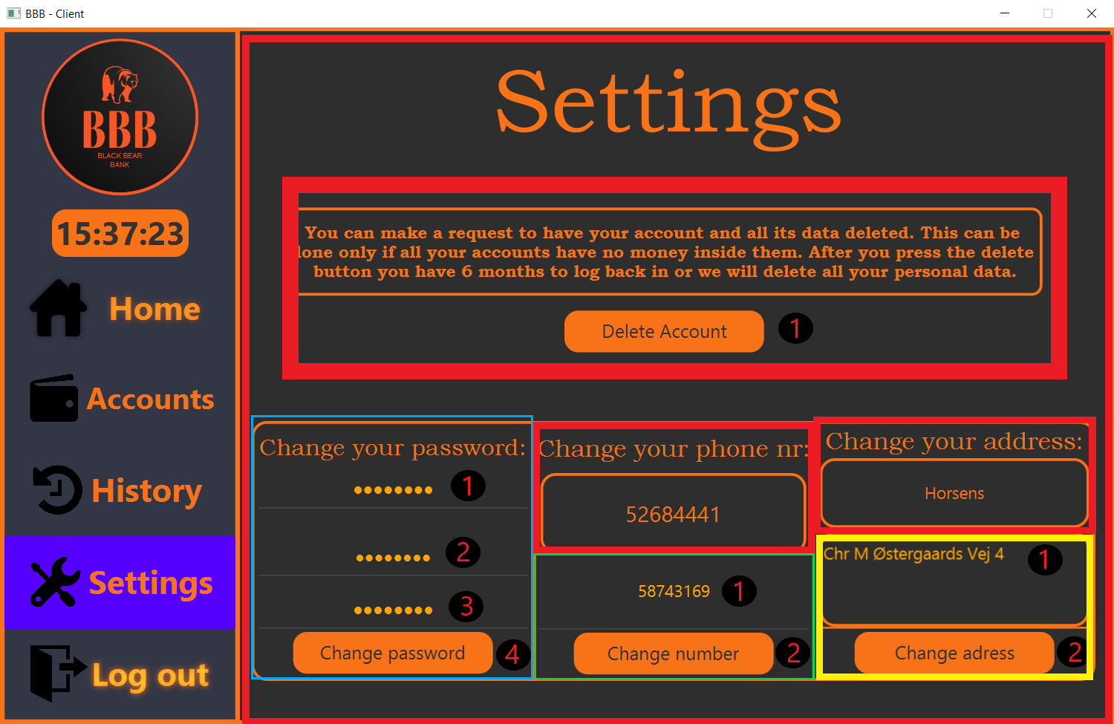

This is all what you must know for client panel – now its time to learn how manager panel works.

*Note: Manager and Staff panel are identically the same – excluding the thing that manager can do some action more, therefore we decided to include only managers panel.*

**Accept new clients panel**

This section is designed for manager to accept new clients. *See below how it works:*

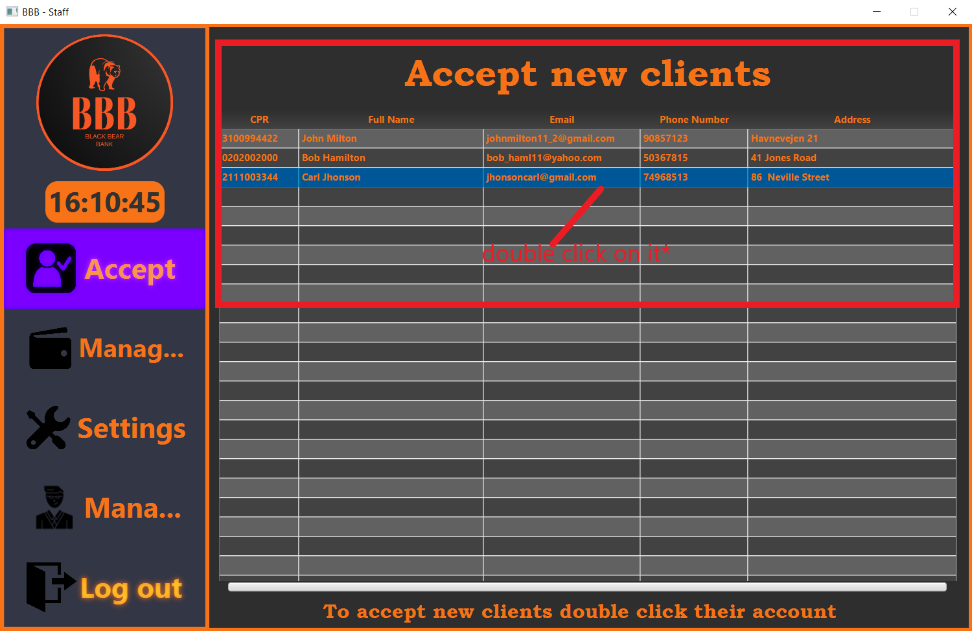

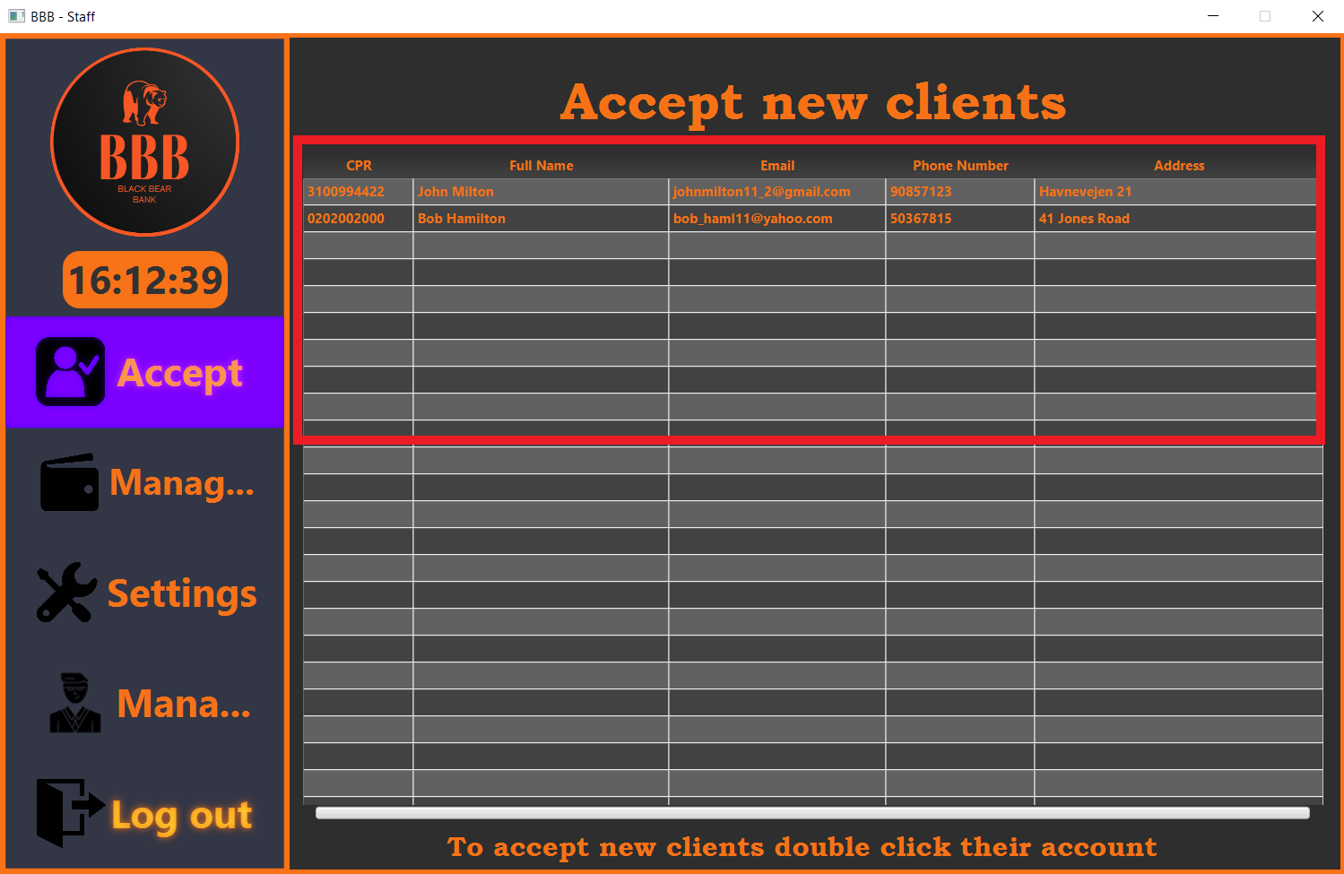

Congratulations, a new client received access to the usage of the application (his account was accepted).

**Manage clients**

Mange clients panel gives you access to retrieve clients data, to accept loans and to change a client password based on his need or security reasons.

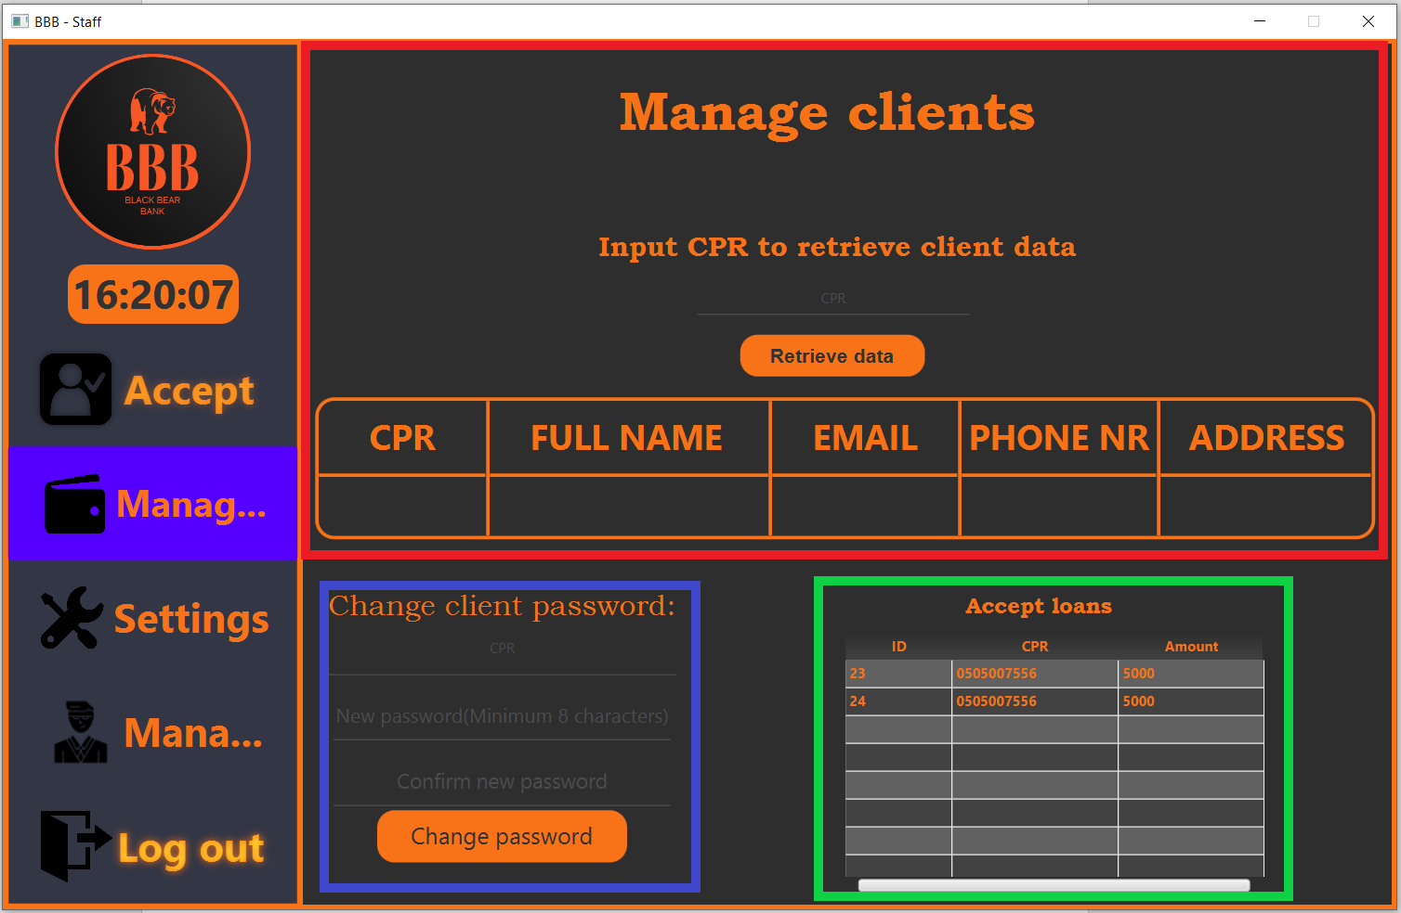

Red border is the panel where you can retrieve clients data. *See below how it works*:

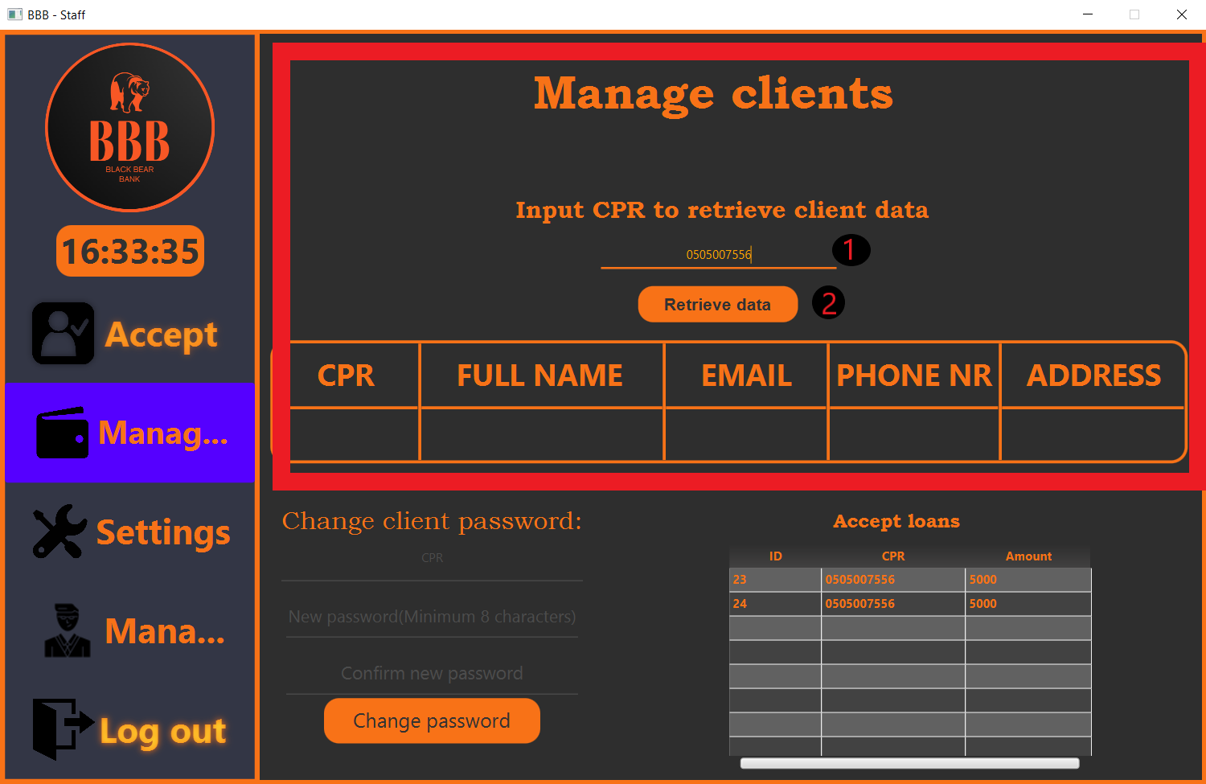

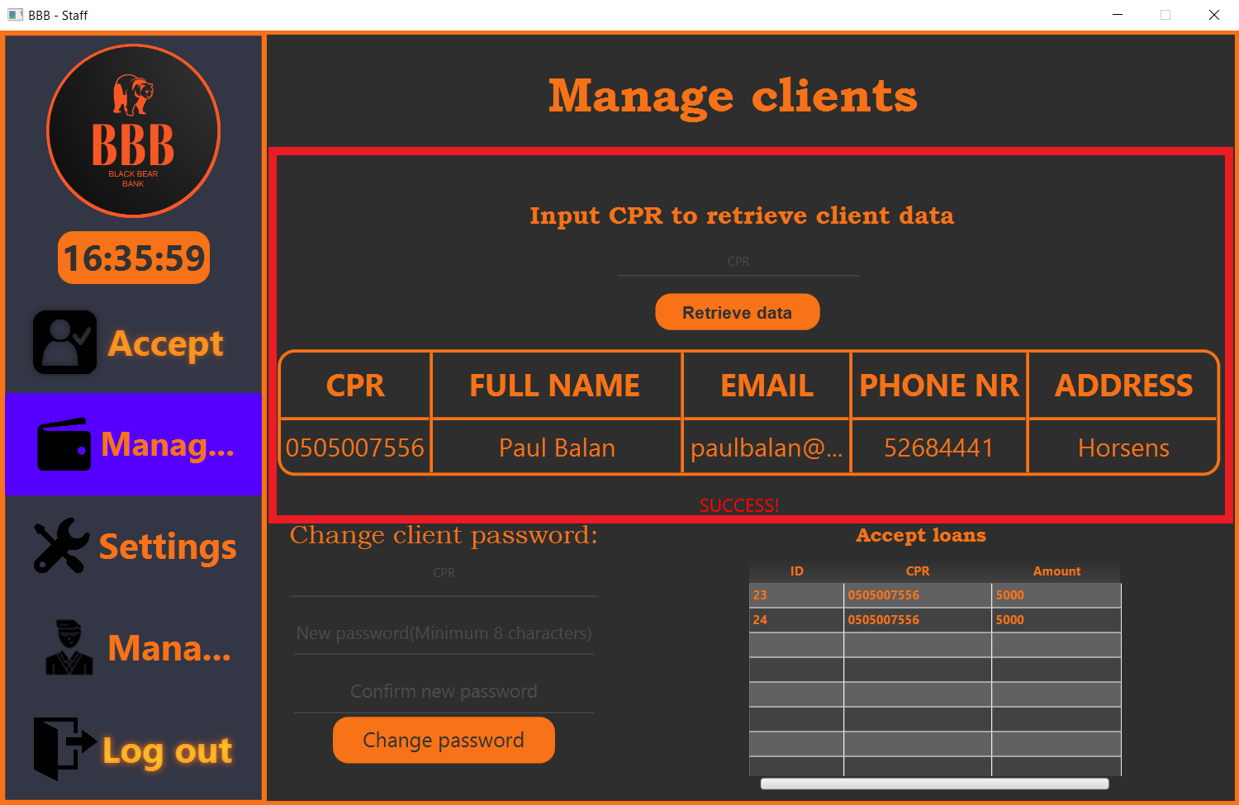

Data retrieved successfully.

Blue border for changing client password and green border for accepting loans. *See below how it works:*

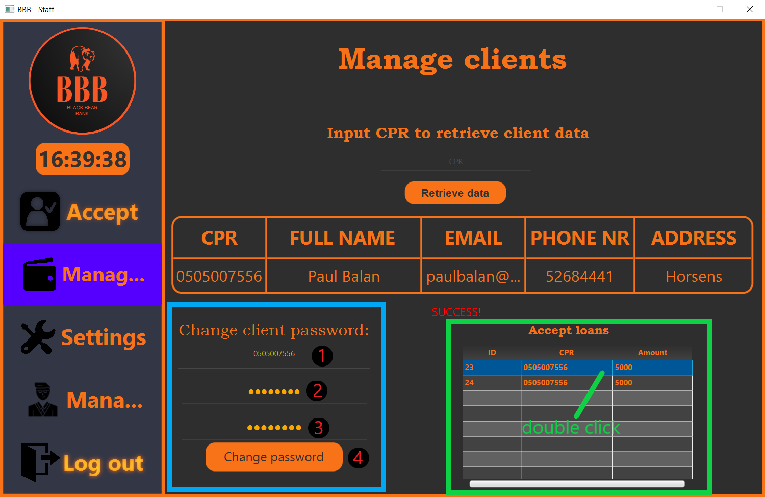

**Settings panel**

Settings panel is the panel used for changing the password*. See below how it works:*

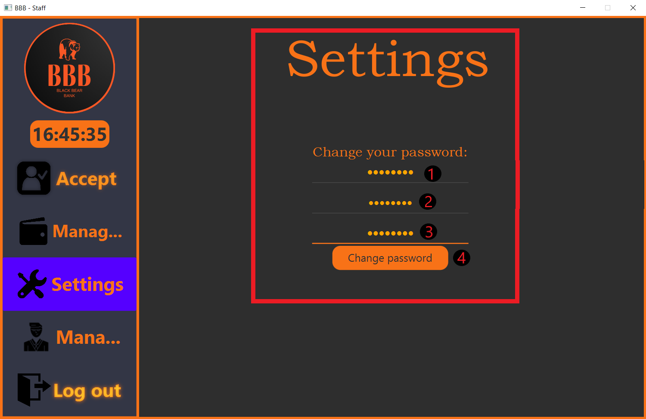

**Manager panel**

Manager panel is one of the most important one to work with for a manager.It allows manager to work with the most important features based on his position.

This panel contains two tables with information regarding the exchange rate and all staff and managers , and 4 panels to worki with:change staff password , to delete/create new staff and to edit the exchange rate.

*Note: There is also an important button wich allows you to shut down the server (be careful with it).*

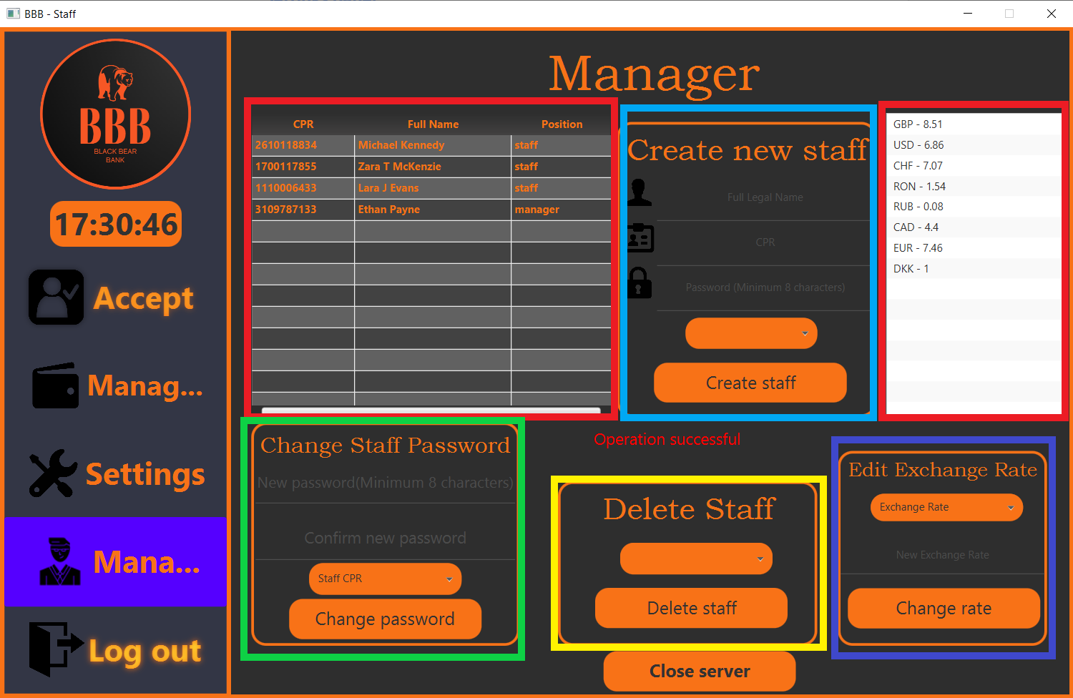

To create new staff*. See below how it works.*

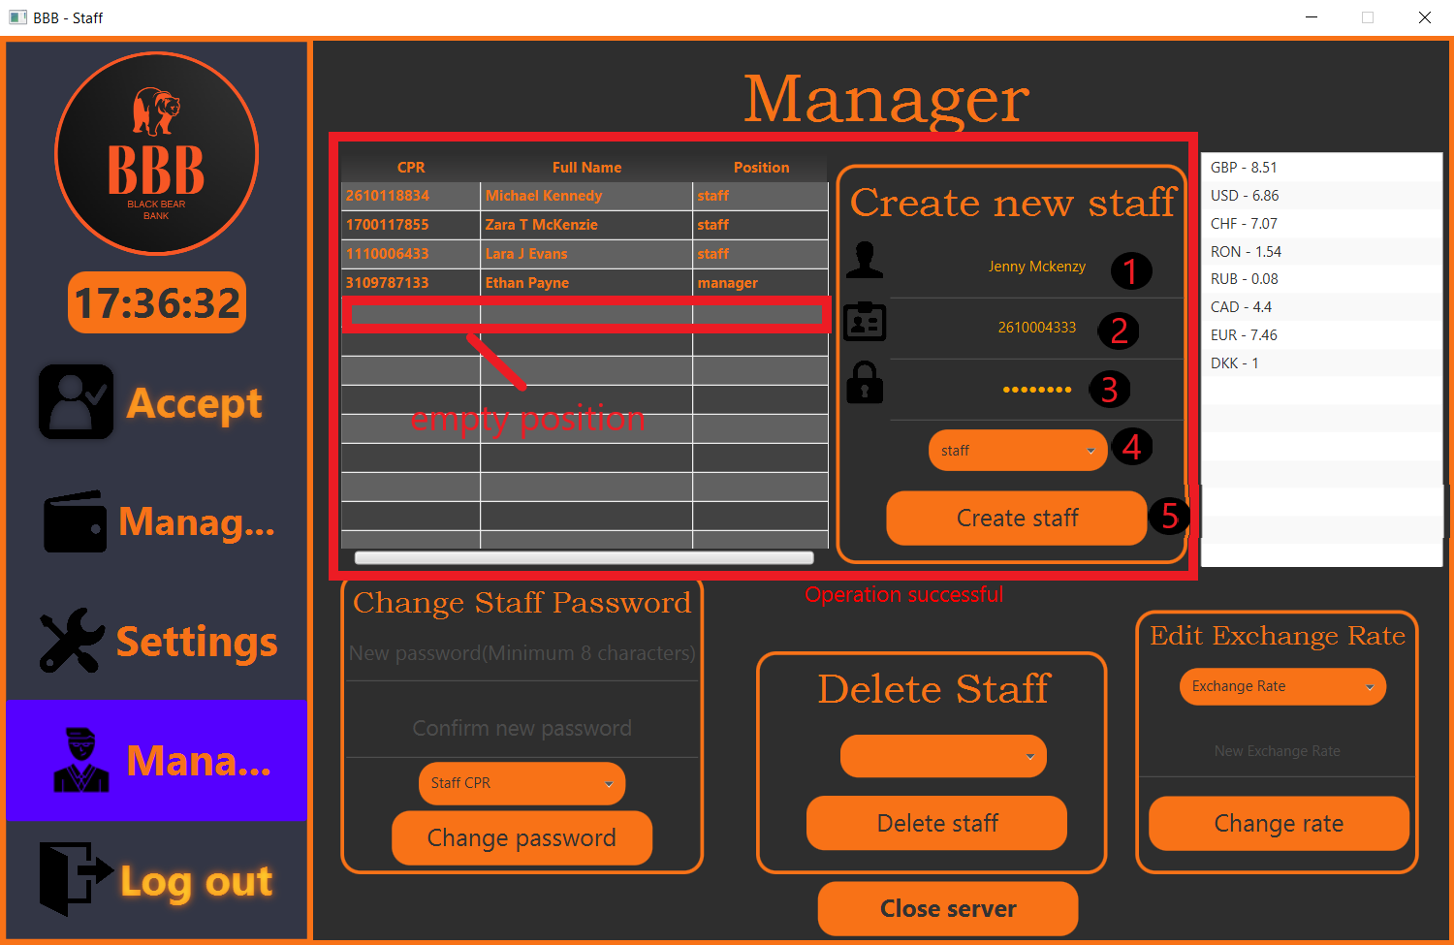

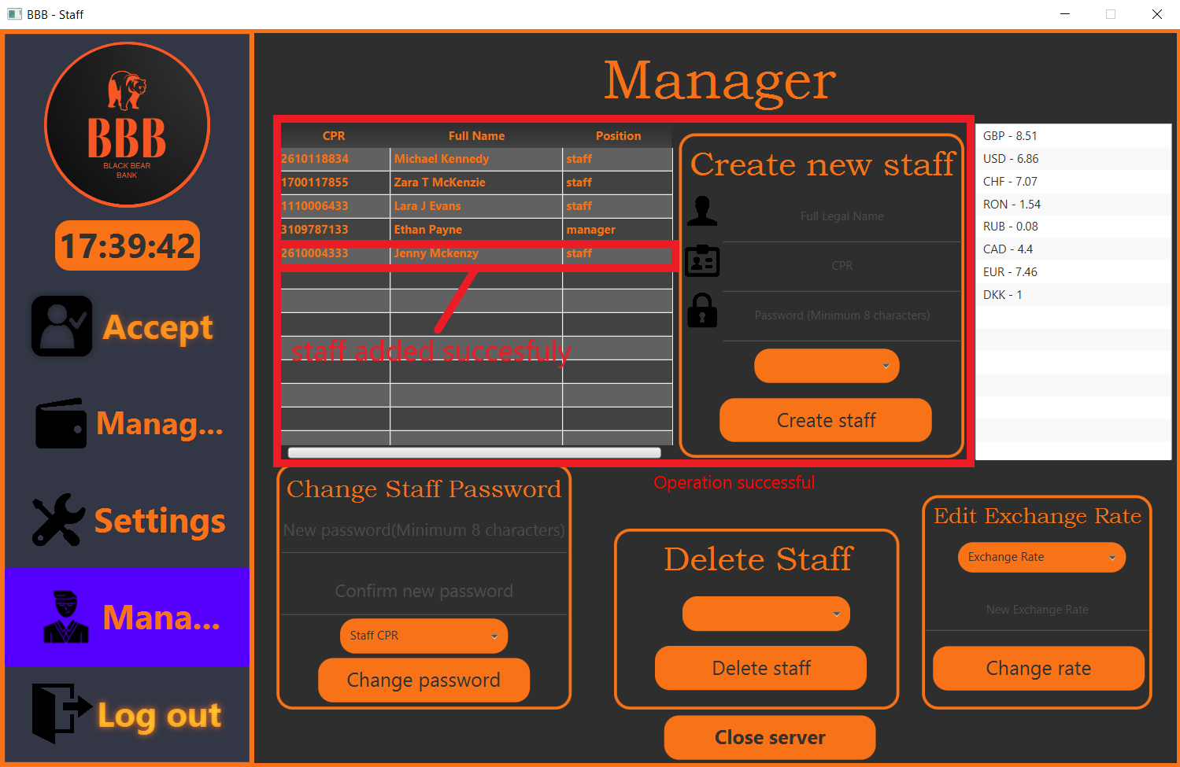

To delete staff. *See below how it works: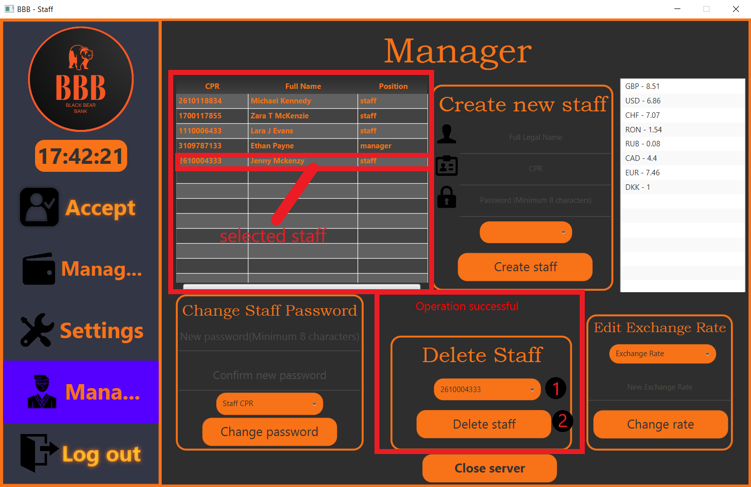*

*\*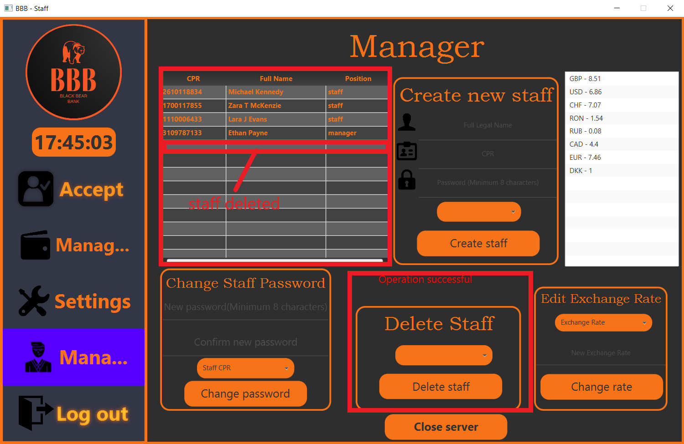

Change staff’s password.*See below how it works*: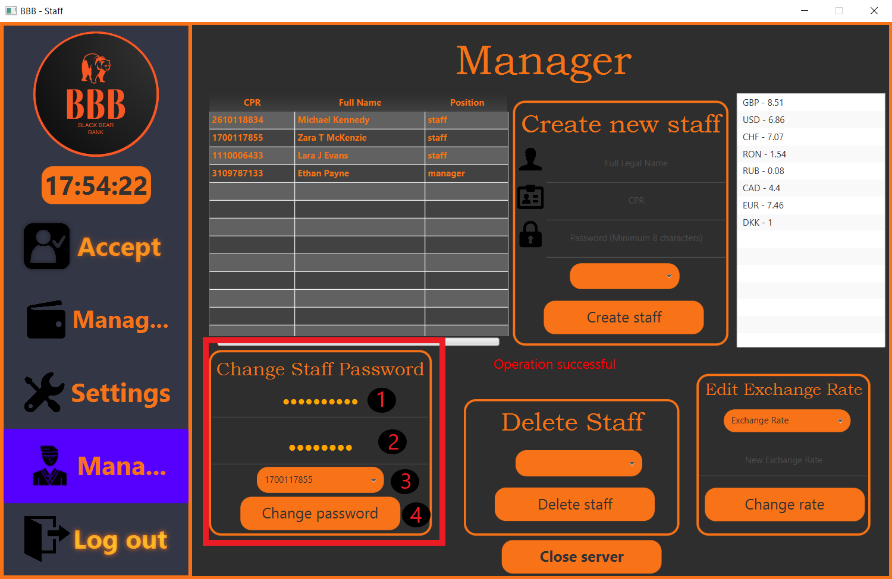

Edit exchange rate.*See below how it works:*

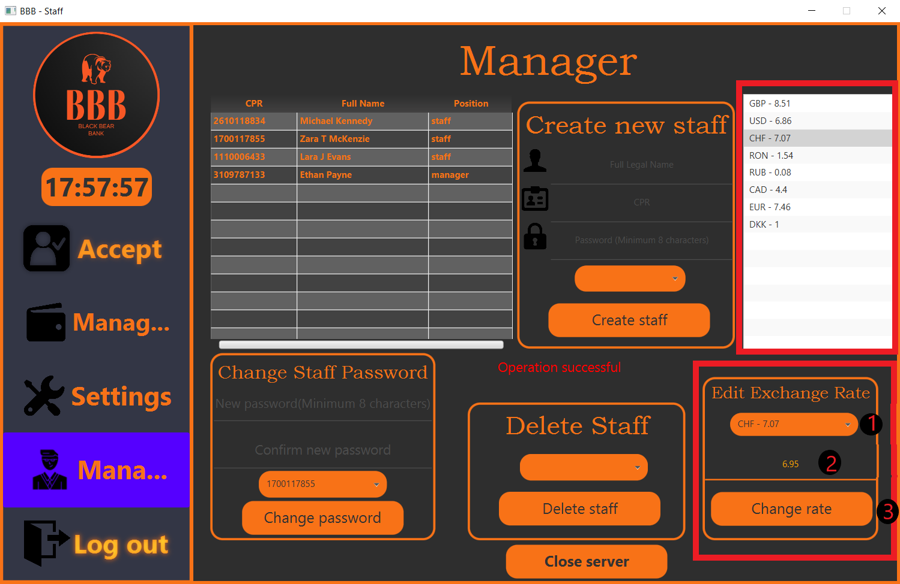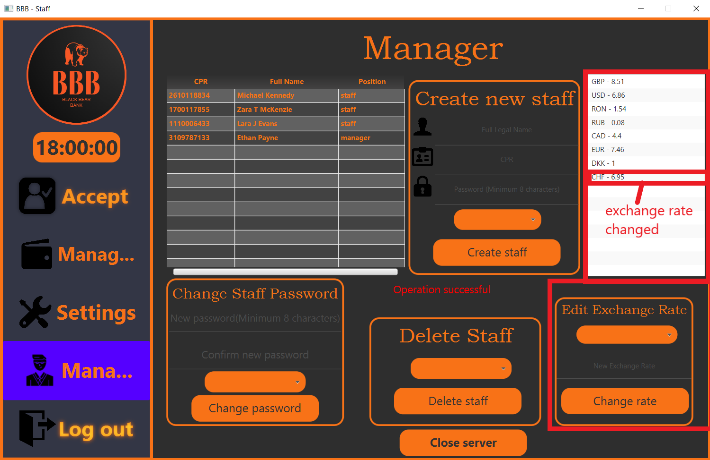

This was the last thing you had to knew before using our application.

Thank you very much for your patience and thank you for using our application and hope that you will find us the best application for mananging your finances.